Write a code using Terraform that deploys and achieves the following:-
- Create an EC2 Instance on AWS Cloud using the below-mentioned ubuntu AMI and instance_type. Or, (You can use of your choice as well) ami = "ami-0461b1436c9b3c1a3" instance_type = "t2.micro"
- Install a web server on the same EC2 Instance. The web server should listen on port 8080.
- Create a Docker-compose file for the project:https://github.com/betawins/cricbuzz-docker-hello-world.gitand point it to port 8000.
- Make the web server point to the above service so that 8080 returns the response from the Docker service.
- Configure to Save the Logs in the location /var/log/cb.log
- Write the Log rotate configuration for the above file
1. Project structure
Create a folder:
terraform-cricbuzz/
│
├── provider.tf
├── variables.tf
├── main.tf
├── outputs.tf
└── terraform.tfvars
On Windows:
mkdir terraform-cricbuzz
cd terraform-cricbuzz
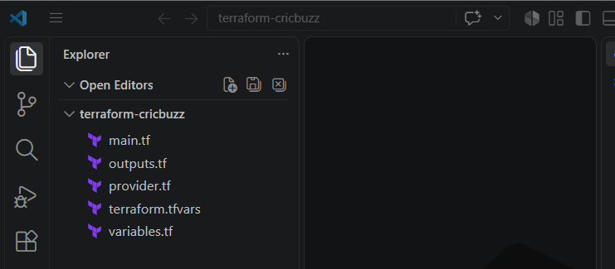

2. provider.tf
Create:
terraform {
required_version = ">= 1.5.0"

required_providers {
aws = {
source = "hashicorp/aws"
version = "~> 6.0"
}
}
}

provider "aws" {
region = var.aws_region
}

3. variables.tf
Create:
variable "aws_region" {
description = "AWS region"
type = string
default = "us-east-1"
}

variable "ami_id" {
description = "Ubuntu AMI ID"
type = string
default = "ami-098f18a6382fb4b2d"
}

variable "instance_type" {
description = "EC2 instance type"
type = string
default = "t3.micro"
}

variable "key_name" {
description = "Existing AWS EC2 Key Pair name"
type = string
}
Important
The AMI ID is region-specific.
The AMI you provided:
ami-098f18a6382fb4b2d
must exist in the region you use.
We are initially using:
us-east-1
If AWS says:
InvalidAMIID.NotFound
then either use the correct region or replace the AMI with a current Ubuntu AMI for that region.

4. terraform.tfvars
Create:
aws_region = "us-east-1"
ami_id = "ami-098f18a6382fb4b2d"
instance_type = "t3.micro"

key_name = "YOUR-KEY-PAIR-NAME"
For example:
key_name = "docker-practice-key"
Use the EC2 Key Pair name, not the .pem filename.

5. main.tf
This is the main Terraform code.
# -----------------------------------------
# Data sources
# -----------------------------------------

data "aws_vpc" "default" {
default = true
}

data "aws_subnets" "default" {
filter {
name = "vpc-id"
values = [data.aws_vpc.default.id]
}
}

# -----------------------------------------
# Security Group
# -----------------------------------------

resource "aws_security_group" "cricbuzz_sg" {

name = "cricbuzz-sg"
description = "Allow SSH and HTTP 8080"
vpc_id = data.aws_vpc.default.id

# SSH
ingress {
description = "SSH"
from_port = 22
to_port = 22
protocol = "tcp"

cidr_blocks = ["0.0.0.0/0"]
}

# Nginx
ingress {
description = "Nginx port 8080"
from_port = 8080
to_port = 8080
protocol = "tcp"

cidr_blocks = ["0.0.0.0/0"]
}

# Outbound
egress {
from_port = 0
to_port = 0
protocol = "-1"

cidr_blocks = ["0.0.0.0/0"]
}

tags = {
Name = "cricbuzz-sg"
}
}

# -----------------------------------------
# EC2 Instance
# -----------------------------------------

resource "aws_instance" "cricbuzz_server" {

ami = var.ami_id
instance_type = var.instance_type

subnet_id = data.aws_subnets.default.ids[0]

key_name = var.key_name

vpc_security_group_ids = [
aws_security_group.cricbuzz_sg.id
]

user_data = <<-EOF
#!/bin/bash

set -e

# -----------------------------------------
# Update packages
# -----------------------------------------

apt-get update -y
apt-get upgrade -y

# -----------------------------------------
# Install required packages
# -----------------------------------------

apt-get install -y \
docker.io \
docker-compose-v2 \
nginx \
git \
curl \
logrotate

# -----------------------------------------
# Start Docker
# -----------------------------------------

systemctl enable docker
systemctl start docker

# -----------------------------------------
# Start Nginx
# -----------------------------------------

systemctl enable nginx
systemctl start nginx

# -----------------------------------------
# Clone application repository
# -----------------------------------------

mkdir -p /opt/cricbuzz

cd /opt/cricbuzz

if [ ! -d "/opt/cricbuzz/cricbuzz-docker-hello-world" ]; then

git clone \
https://github.com/betawins/cricbuzz-docker-hello-world.git \
/opt/cricbuzz/cricbuzz-docker-hello-world

fi

cd /opt/cricbuzz/cricbuzz-docker-hello-world

# -----------------------------------------
# Create Docker Compose file
# -----------------------------------------

cat > docker-compose.yml <<'COMPOSE'
services:

cricbuzz:
build:
context: .

container_name: cricbuzz

restart: unless-stopped

ports:
- "127.0.0.1:8000:8080"
COMPOSE

# -----------------------------------------
# Start Docker Compose
# -----------------------------------------

cd /opt/cricbuzz/cricbuzz-docker-hello-world

docker compose up -d --build

# -----------------------------------------
# Configure Nginx
# -----------------------------------------

cat > /etc/nginx/sites-available/cricbuzz <<'NGINX'

server {

listen 8080;
listen [::]:8080;

server_name _;

# Application access logs
access_log /var/log/cb.log;

# Error logs
error_log /var/log/nginx/cricbuzz_error.log;

location / {

proxy_pass http://127.0.0.1:8000;

proxy_http_version 1.1;

proxy_set_header Host \$host;
proxy_set_header X-Real-IP \$remote_addr;
proxy_set_header X-Forwarded-For \$proxy_add_x_forwarded_for;
proxy_set_header X-Forwarded-Proto \$scheme;

}
}

NGINX

# -----------------------------------------
# Enable Nginx configuration
# -----------------------------------------

rm -f /etc/nginx/sites-enabled/default

ln -sf \
/etc/nginx/sites-available/cricbuzz \
/etc/nginx/sites-enabled/cricbuzz

# -----------------------------------------
# Test Nginx configuration
# -----------------------------------------

nginx -t

# -----------------------------------------
# Restart Nginx
# -----------------------------------------

systemctl restart nginx

# -----------------------------------------
# Logrotate configuration
# -----------------------------------------

cat > /etc/logrotate.d/cb <<'LOGROTATE'

/var/log/cb.log {

daily

rotate 7

missingok

notifempty

compress

delaycompress

copytruncate

}

LOGROTATE

# -----------------------------------------
# Set permissions
# -----------------------------------------

touch /var/log/cb.log

chmod 644 /var/log/cb.log

# -----------------------------------------
# Final verification
# -----------------------------------------

systemctl enable nginx
systemctl enable docker

EOF

tags = {
Name = "Cricbuzz-Terraform-Server"
}
}

6. outputs.tf
Create:
output "instance_id" {
description = "EC2 Instance ID"
value = aws_instance.cricbuzz_server.id
}

output "public_ip" {
description = "EC2 Public IP"
value = aws_instance.cricbuzz_server.public_ip
}

output "application_url" {
description = "Application URL"
value = "http://${aws_instance.cricbuzz_server.public_ip}:8080"
}

output "ssh_command" {
description = "SSH command"
value = "ssh -i <YOUR-PEM-FILE> ubuntu@${aws_instance.cricbuzz_server.public_ip}"
}

7. Initialize Terraform
From your project directory:
terraform init
You should see something similar to:
Initializing the backend...

Initializing provider plugins...

- Installing hashicorp/aws...

Terraform has been successfully initialized!
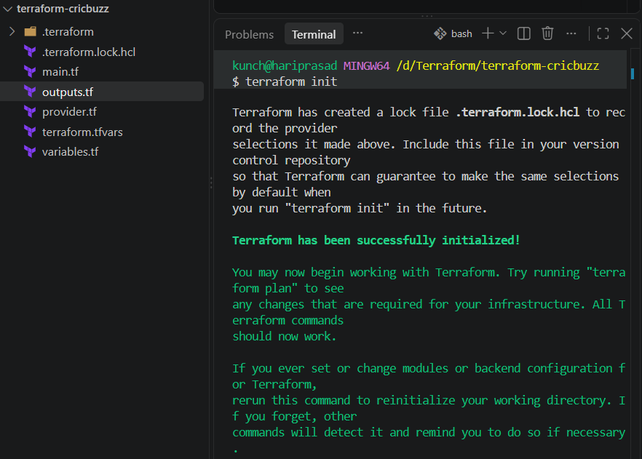

8. Format the Terraform files
Run:
terraform fmt
Then:
terraform validate
Expected:
Success! The configuration is valid.
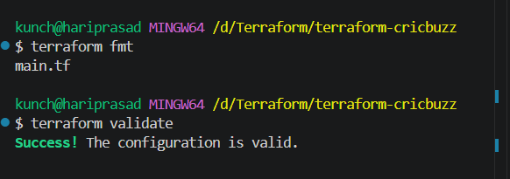

9. Run Terraform Plan
terraform plan
Terraform should show approximately:
Plan: 2 to add, 0 to change, 0 to destroy.
The two main resources are:
aws_security_group.cricbuzz_sg
aws_instance.cricbuzz_server
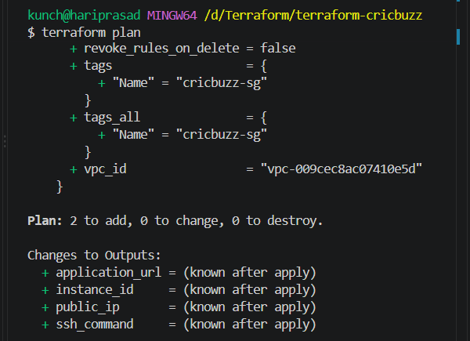

10. Deploy
Run:
terraform apply
Terraform asks:
Do you want to perform these actions?
Enter a value:
Enter:
yes
After successful deployment:
Apply complete! Resources: 2 added, 0 changed, 0 destroyed.
Then:
terraform output
You should get something similar to:
application_url = "http://54.xx.xx.xx:8080"
instance_id = "i-xxxxxxxxxxxxxxxxx"
public_ip = "54.xx.xx.xx"
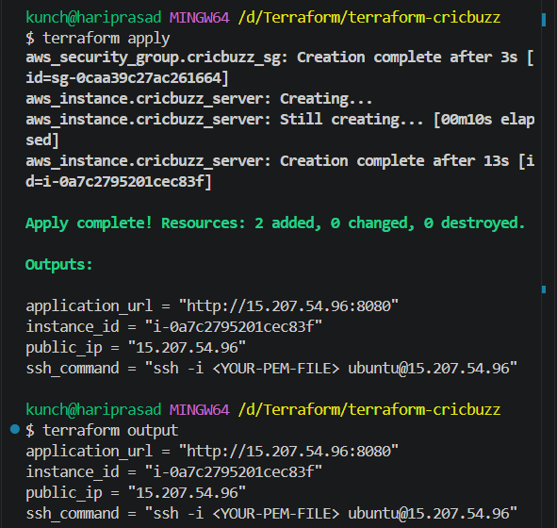

11. Wait for EC2 user-data to complete
This is important.
Terraform considers the EC2 instance created when AWS creates the instance. It does not necessarily wait for every user_data command to finish.
Therefore wait approximately 2–5 minutes.
Then SSH into the server.
ssh -i "/c/Users/kunch/Downloads/docker-practice-key.pem" ec2-user@ec2-15-207-54-96.ap-south-1.compute.amazonaws.com
Example:
ssh -i docker-practice-key.pem ubuntu@54.xx.xx.xx
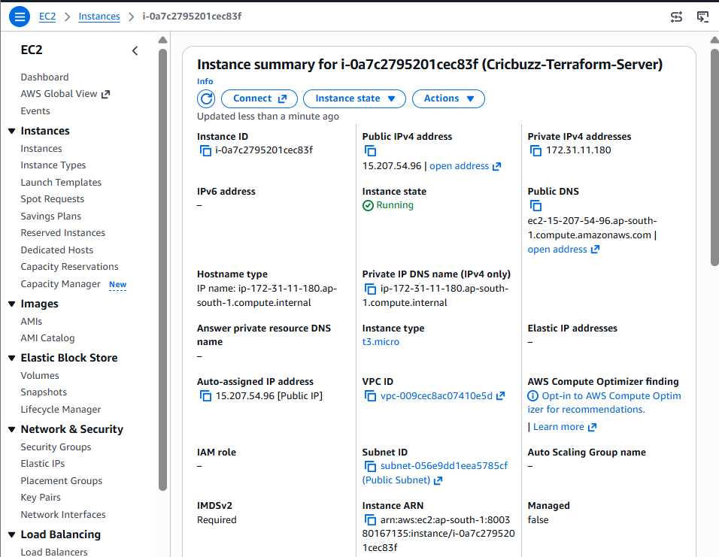

12. Verify Docker
Run:
docker --version
Then:
docker compose version
Expected something like:
Docker version ...
Docker Compose version ...
Check Docker:
sudo systemctl status docker
You want:
Active: active (running)
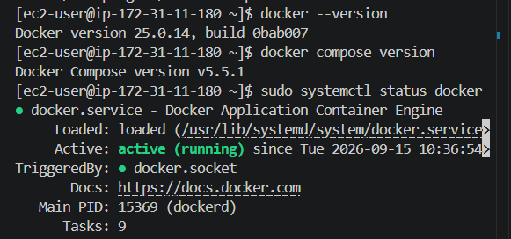

13. Verify Docker Compose
Go to:
cd /opt/cricbuzz/cricbuzz-docker-hello-world
Check files:
ls -la
You should see:
Dockerfile
hello_world.go
docker-compose.yml
...
Check the Compose file:
cat docker-compose.yml
It should be:
services:

cricbuzz:
build:
context: .

container_name: cricbuzz

restart: unless-stopped

ports:
- "127.0.0.1:8000:8080"
The mapping means:
EC2 localhost:8000
|
v
Container:8080
Docker port publishing follows the HOST_PORT:CONTAINER_PORT model.
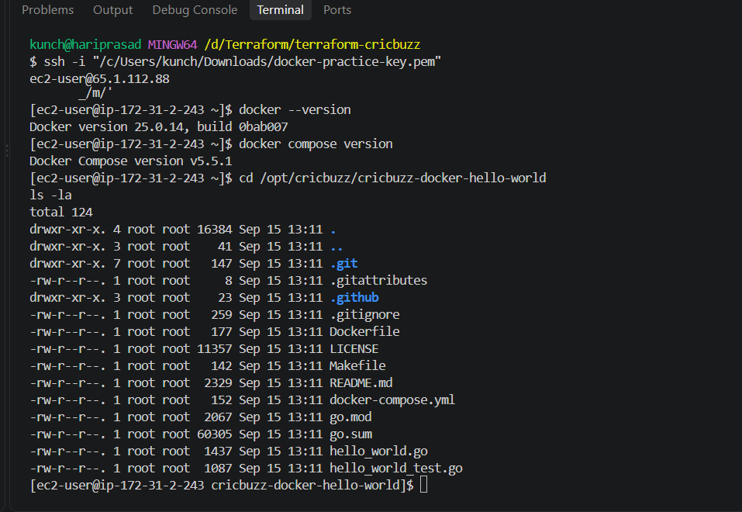
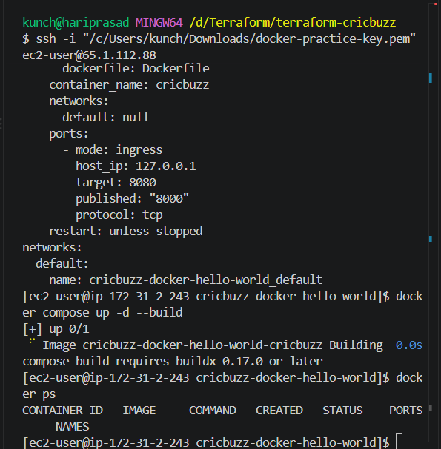
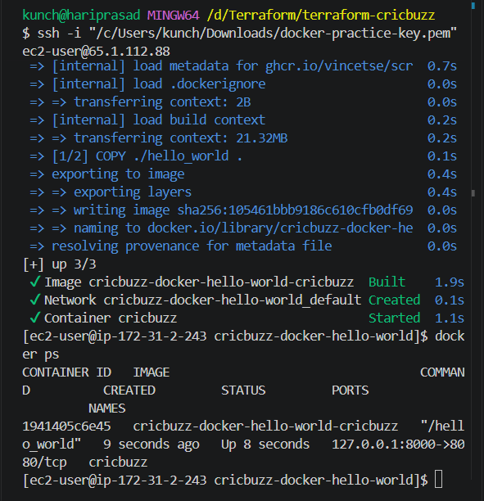

14. Check Docker container
Run:
docker ps
You should see:
CONTAINER ID IMAGE PORTS
xxxxxxxx ... 127.0.0.1:8000->8080/tcp
Now test the Docker application directly:
curl http://localhost:8000
You should get the Hello World response.
The GitHub repository documents the application as an HTTP service and shows it being published from host port 8000 to container port 8080.
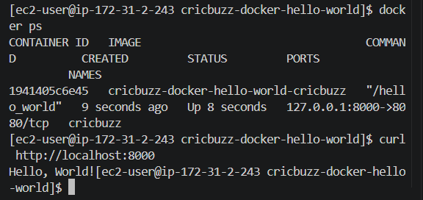

15. Verify Nginx
Run:
sudo systemctl status nginx
Then:
sudo nginx -t
Expected:
syntax is ok
test is successful
Check Nginx listening ports:
sudo ss -lntp | grep 8080
You should see something similar to:
LISTEN 0 511 0.0.0.0:8080
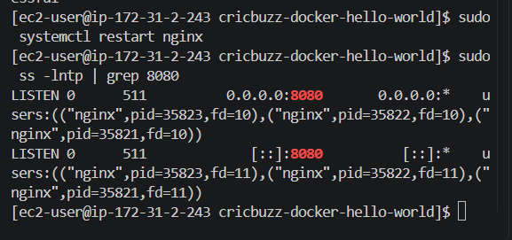

16. Test the complete flow
Now run:
curl http://localhost:8080
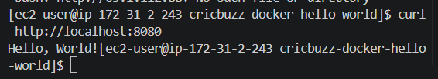
The request flow is:
curl localhost:8080
|
v
Nginx
|
| proxy_pass
v
localhost:8000
|
v
Docker Container
|
v
Application :8080
So requirement #4 is satisfied:
Web server on port 8080 forwards requests to the Docker service.

17. Test from your Windows browser
Get the public IP:
terraform output public_ip
Suppose:
54.123.45.67
Open:
http://54.123.45.67:8080
You should get:
Hello, World!
or the response generated by the application.
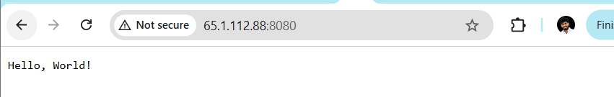

18. Why we don't expose port 8000 publicly
Notice this:
ports:
- "127.0.0.1:8000:8080"
Instead of:
ports:
- "8000:8080"
This is intentional.
The application is only accessible locally:
127.0.0.1:8000
Internet traffic comes through:
EC2:8080
and Nginx forwards it.
Therefore:
Internet
|
| :8080
v
Nginx
|
| :8000
v
Docker
Port 8000 does not need to be opened in the security group.
This is also a cleaner architecture because Docker's application isn't directly exposed to the Internet.

19. Verify /var/log/cb.log
Run:
sudo ls -lh /var/log/cb.log
Then:
sudo tail -f /var/log/cb.log
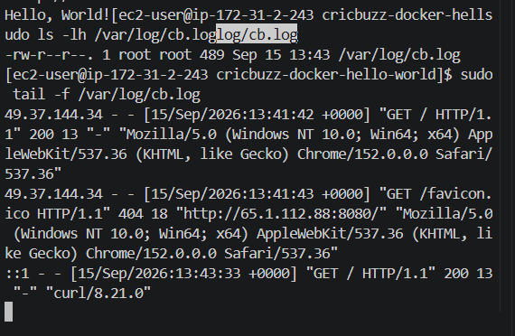
Open your browser:
http://PUBLIC-IP:8080
You should see a log entry similar to:
PUBLIC-IP - - [15/Sep/2026:...] "GET / HTTP/1.1" 200 ...
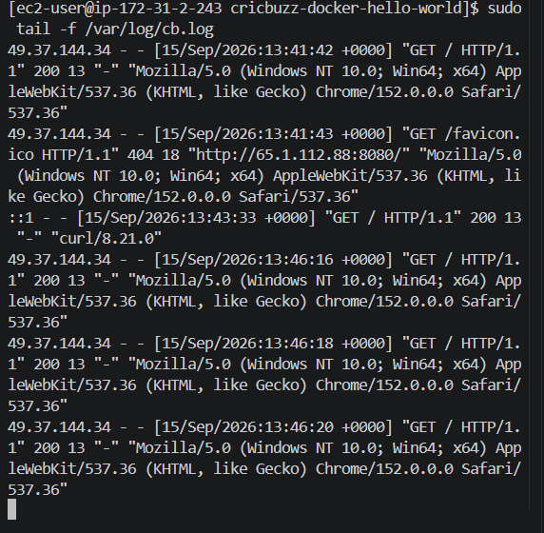
You can also check:
sudo cat /var/log/cb.log
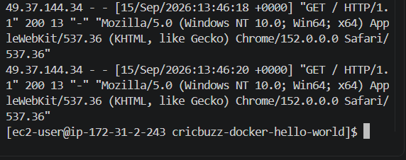

20. Test logrotate
We configured:
/etc/logrotate.d/cb
Check it:
sudo cat /etc/logrotate.d/cb
It should contain:
/var/log/cb.log {

daily

rotate 7

missingok

notifempty

compress

delaycompress

copytruncate

}
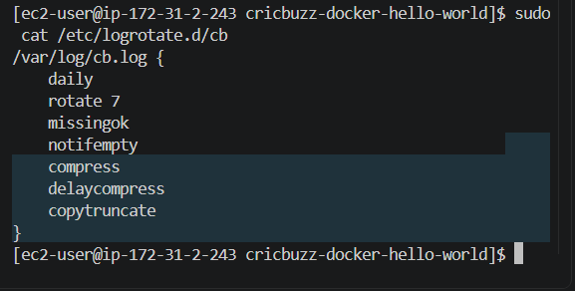
Meaning
Configuration | Meaning
daily | Rotate every day
rotate 7 | Keep 7 old logs
missingok | Don't report error if file doesn't exist
notifempty | Don't rotate empty logs
compress | Compress old logs
delaycompress | Compress from the second-oldest rotation
copytruncate | Copy and truncate active log

21. Manually test logrotate
Run:
sudo logrotate -f /etc/logrotate.d/cb
Then:
ls -lh /var/log/cb*
You may see:
/var/log/cb.log
/var/log/cb.log.1
After subsequent rotations:
cb.log
cb.log.1
cb.log.2.gz
cb.log.3.gz
...
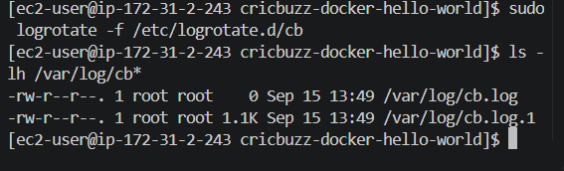

22. Check the complete setup
At this point run these commands:
EC2
hostname
Docker
docker ps
Docker Compose
docker compose ps
Application
curl localhost:8000
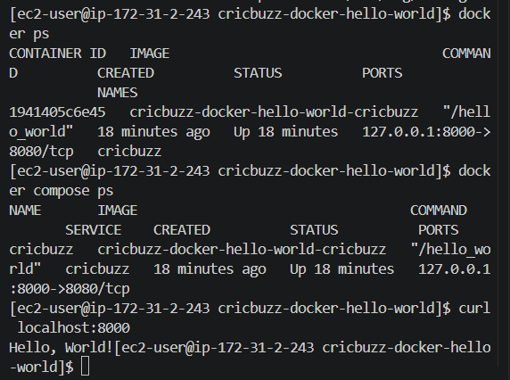
Nginx
sudo systemctl status nginx
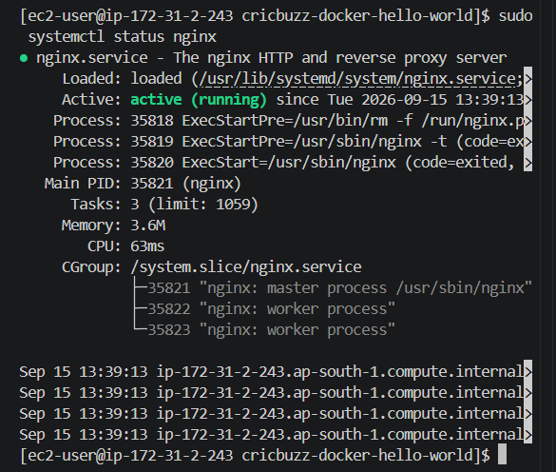
Nginx port
sudo ss -lntp | grep 8080
Nginx → Docker
curl localhost:8080
Logs
sudo tail /var/log/cb.log
Logrotate
sudo logrotate -d /etc/logrotate.d/cb
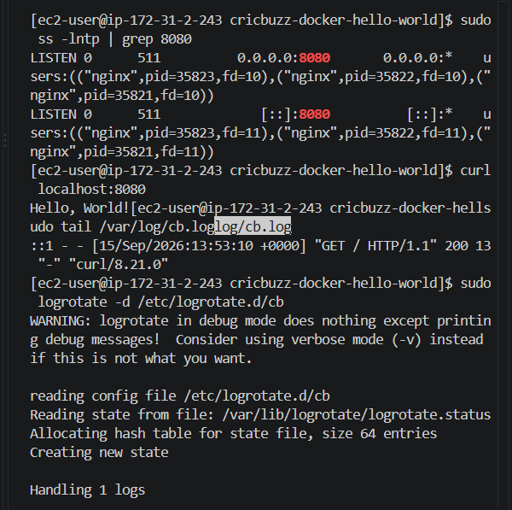

23. Final requirement mapping
Your assignment requirements are now satisfied:
Requirement | Implementation
EC2 Ubuntu | aws_instance.cricbuzz_server
t3.micro | var.instance_type
Ubuntu AMI | var.ami_id
Web server | Nginx
Nginx port | 8080
GitHub project | betawins/cricbuzz-docker-hello-world
Docker Compose | /opt/cricbuzz/cricbuzz-docker-hello-world/docker-compose.yml
Docker host port | 8000
Container port | 8080
Nginx → Docker | proxy_pass http://127.0.0.1:8000
Application log | /var/log/cb.log
Log rotation | /etc/logrotate.d/cb
Internet access | EC2 SG port 8080
The repository itself documents the available /, /health, and /metrics endpoints, so you can also test:
curl http://localhost:8080/health
and:
curl http://localhost:8080/metrics
The repository's documented Docker usage confirms that the application listens on container port 8080 and is normally published on host port 8000.
